**S.NO:1 Exercise 1: Configuring a Basic Spring Application**

**SOLUTION CODE:**

**package** com.library;

**import** org.springframework.boot.CommandLineRunner;

**import** org.springframework.boot.SpringApplication;

**import** org.springframework.boot.autoconfigure.SpringBootApplication;

**import** com.library.service.BookService;

**import** org.springframework.context.annotation.Bean;

@SpringBootApplication

**public** **class** LibraryManagementApplication {

**public** **static** **void** main(String[] args) {

SpringApplication.*run*(LibraryManagementApplication.**class**, args);

}

@Bean

**public** CommandLineRunner run(BookService bookService) {

**return** args -> {

bookService.addBook("Spring Boot in Action");

};

}

}

**OUTPUT:**

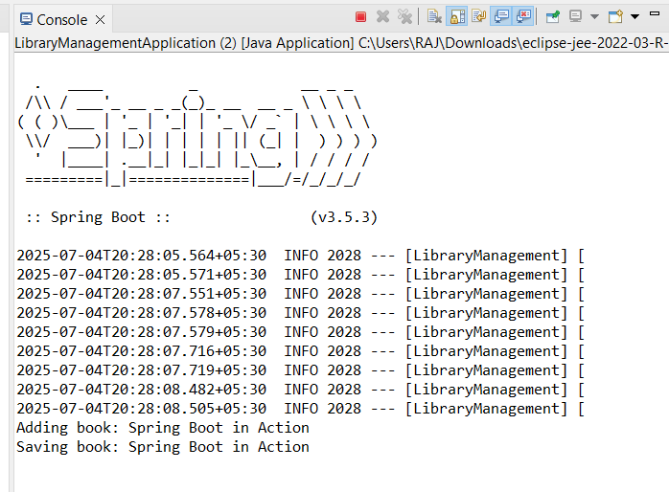

**S.NO: 2 Exercise 2: Implementing Dependency Injection**

**SOLUTION CODE:**

package com.library;

import com.library.service.BookService;

import org.springframework.context.ApplicationContext;

import org.springframework.context.support.ClassPathXmlApplicationContext;

public class LibraryManagementApplication {

public static void main(String[] args) {

ApplicationContext context = new ClassPathXmlApplicationContext("applicationContext.xml");

BookService bookService = (BookService) context.getBean("bookService");

bookService.addBook("Spring in Action");

}

}

**OUTPUT:**

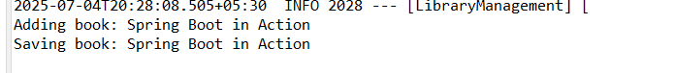

**S.NO:3 Exercise 4: Creating and Configuring a Maven Project**

**SOLUTION CODE:**

package com.library;

import org.springframework.boot.SpringApplication;

import org.springframework.boot.autoconfigure.SpringBootApplication;

@SpringBootApplication

public class LibraryManagementApplication {

public static void main(String[] args) {

SpringApplication.run(LibraryManagementApplication.class, args);

}

**}**

**OUTPUT:**

